



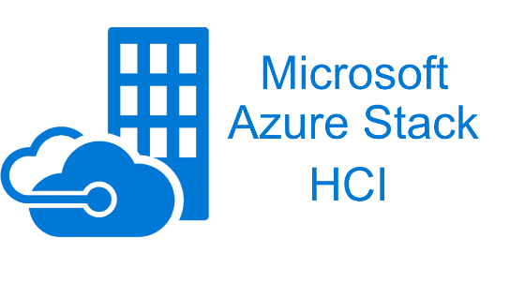



Document Research Project

Research Project

**User Manual** – Vandale Ward, De Herdt Mathias & Demuynck Simon

**Table of contents**

1 General information 2

1.1 Introduction 2

1.2 Objective of this document 2

1.3 Target audience 2

1.4 Research question 2

1.5 Chosen platforms 2

2 Proxmox 3

2.1 Migrating VMs to Proxmox VE 3

2.2 Logging in to the Proxmox VE Web Interface 12

3 Azure Stack HCI 13

3.1 Select your VM 13

3.2 Convert vmdk to vhd 14

3.3 Migrate VM 17

4 Citrix 22

4.1 Installing the vRidance Tool 22

4.2 How to use vRidance 23

# General information

## Introduction

This document has been prepared by Vandale Ward, De Herdt Mathias and Demuynck Simon, third year students at Howest in the field of MCT – IoT Infrastructure Engineer.

In our second semester we have a module called research project in which we have chosen a research question in our field of education. During this module, which lasts three weeks, we will fully research, elaborate and document our research question.

For our research question we have chosen for: “What alternatives exist to VMware vSphere for server virtualization in an enterprise environment and how can an existing VMware environment be migrated to it?” Each of us has chosen a different platform and we are going to work this out in detail. Ward chose Proxmox, Mathias chose Azure Stack HCI and Simon chose Citrix.

What do we want to achieve with this research question? We are looking what platforms are there as alternative for vSphere and on the other hand how do we migrate to them. This is what we are trying to answare with our research question.

## Objective of this document

This document describes in detail how system administrators can migrate their VMware environment to one of our chosen platforms.

## Target audience

System administrators that are looking to migrate their environment to another platform without getting to technical.

## Research question

What alternatives exist to VMware vSphere for server virtualization in an enterprise environment and how can an existing VMware environment be migrated to it?

## Chosen platforms

* Proxmox
* Azure Stack HCI
* Citrix

# Proxmox

## Migrating VMs to Proxmox VE

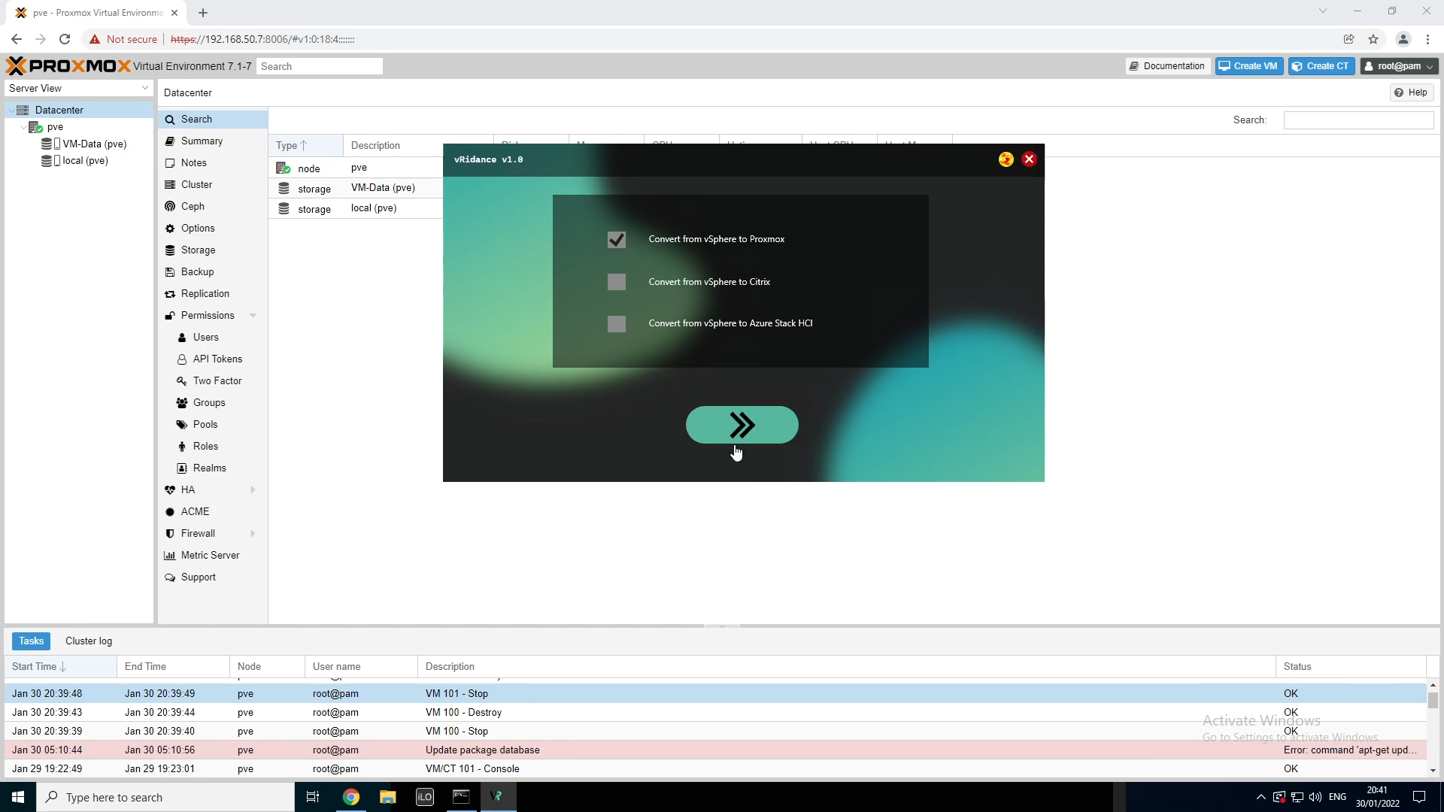

After we’ve clicked on the next button on the start up window, we’ll get the selection of which platform we want to migrate to. Of course we want to migrate to Proxmox here.

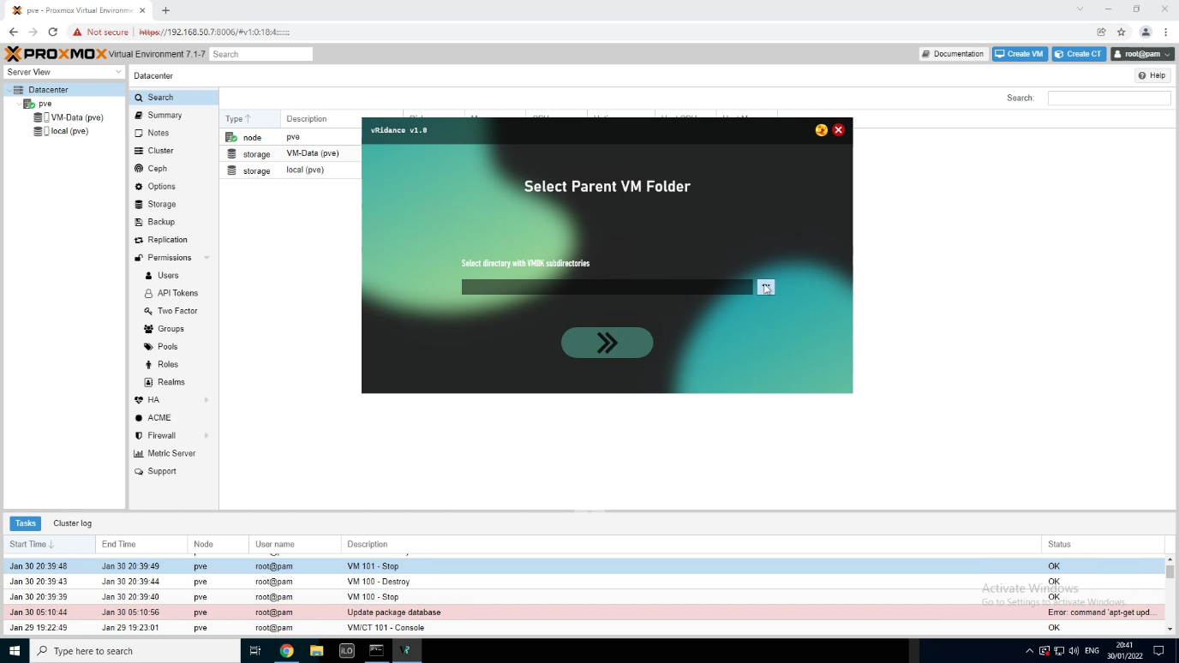

The next step will be choosing the directory that contains all the VMDK files that we want to migrate to Proxmox. It is important that our directory contains subdirectories of the VM we want to create. In each subdirectory we’ll place the corresponding **\*.VMDK** and **\*-flat.VMDK** files. The directory should look like this.

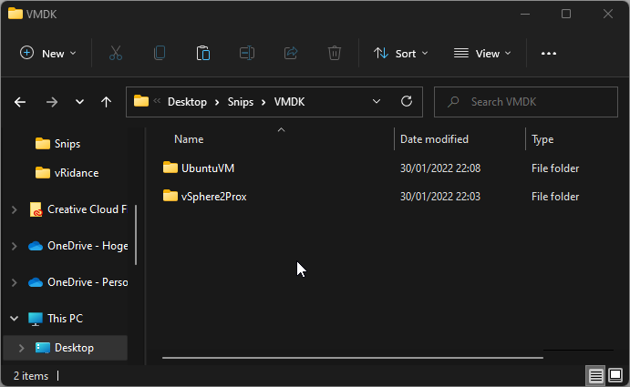 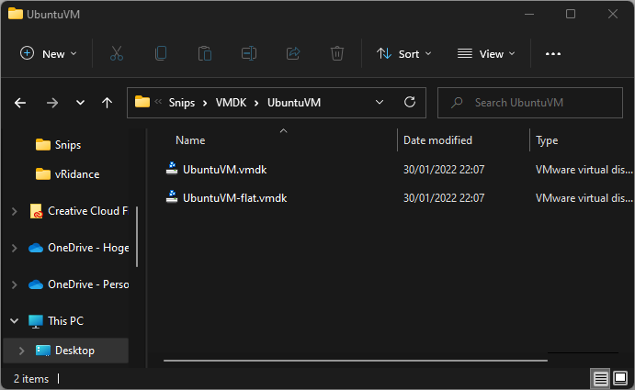

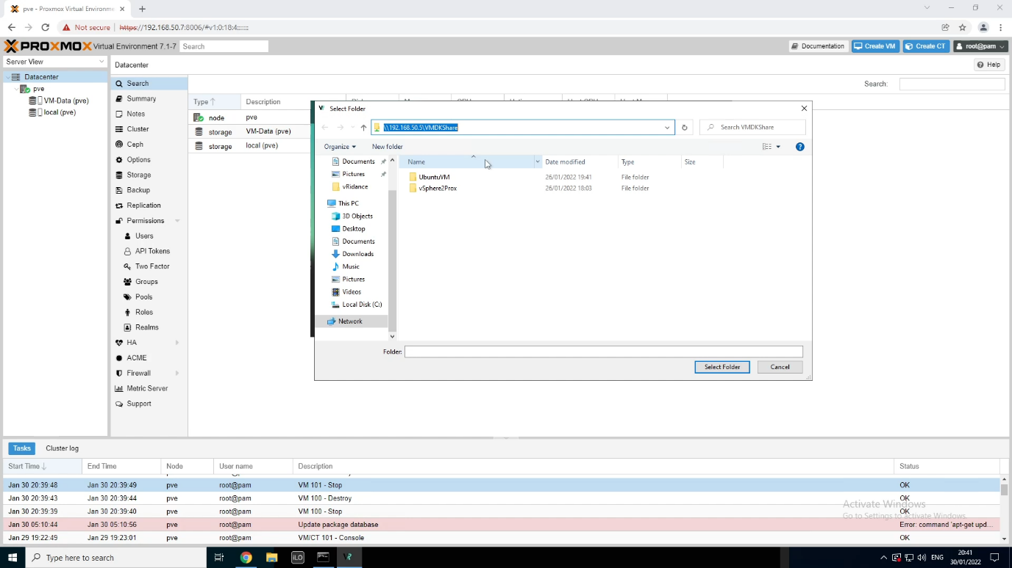

We will be using a shared folder on the network to upload our VMDKs to the Proxmox VE server. This share will also be used for the migration from vSphere to Citrix.

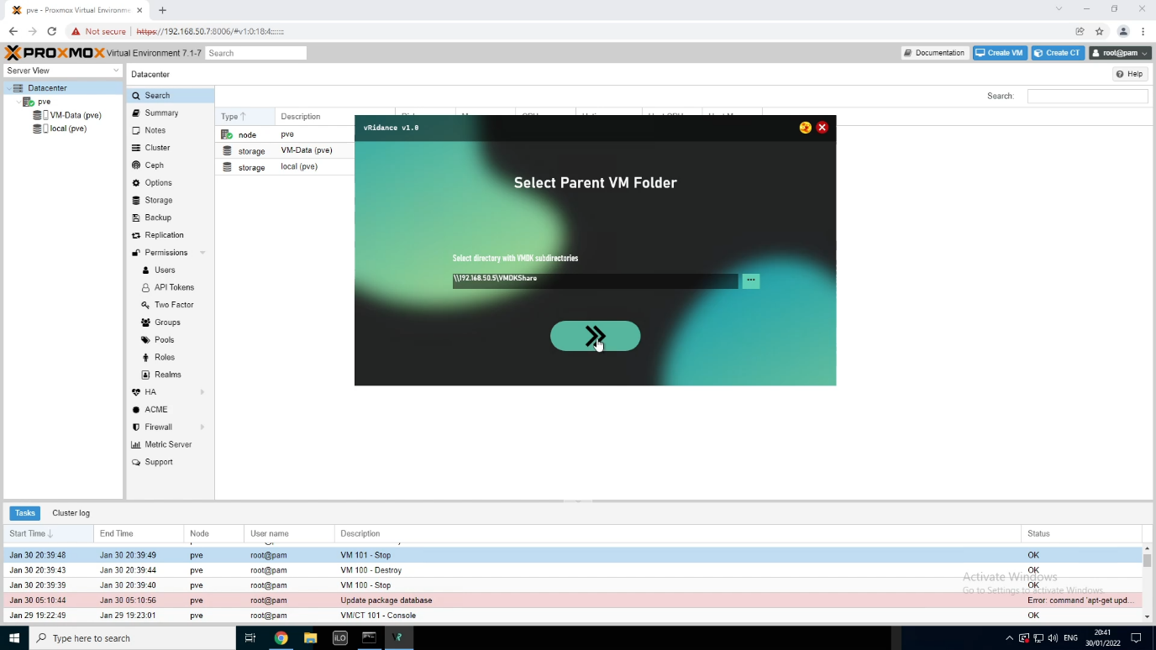

After we have selected our directory, we will click on next. If there is a folder that doesn’t have any VMDK files in it, you will get notified of this before you will be able to continue to the login screen.

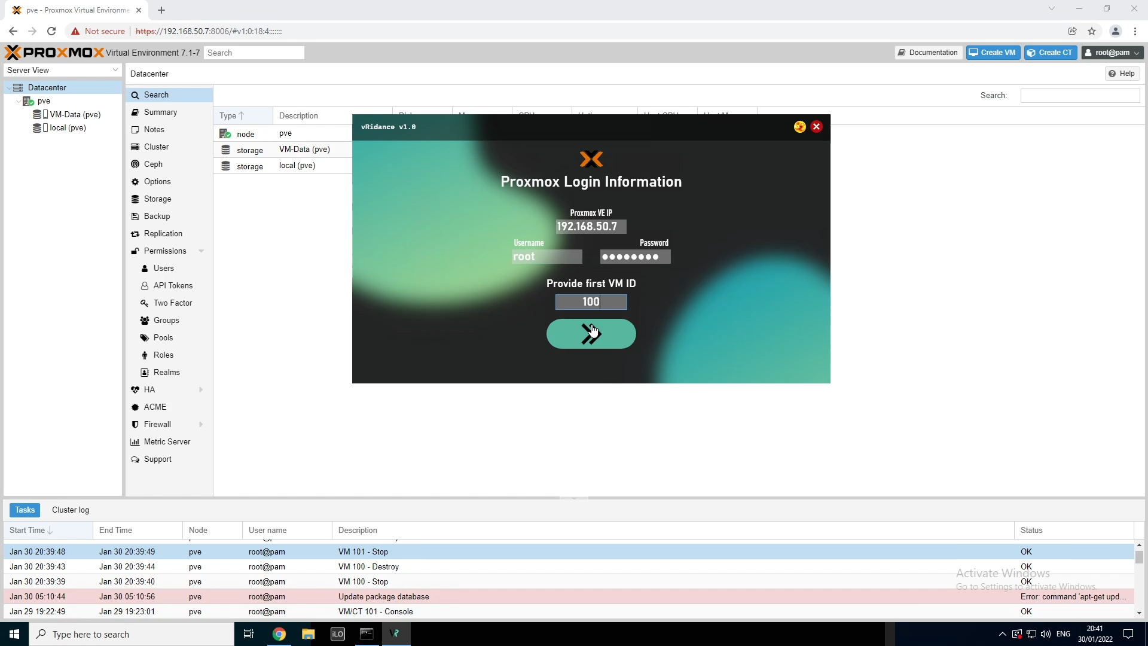

The IP of my Proxmox VE server is 192.168.50.7. The default username for a Proxmox VE installation is root. Fill in the password you’ve chosen during the installation. Here you’ll also be asked to provide the first VM ID. When your Proxmox VE Environment is empty, you can choose with which ID you’ll be starting. When clicking next, the program will try to make a connection to the server. If the connection has been succeeded, you wil be redirected to the migration page.

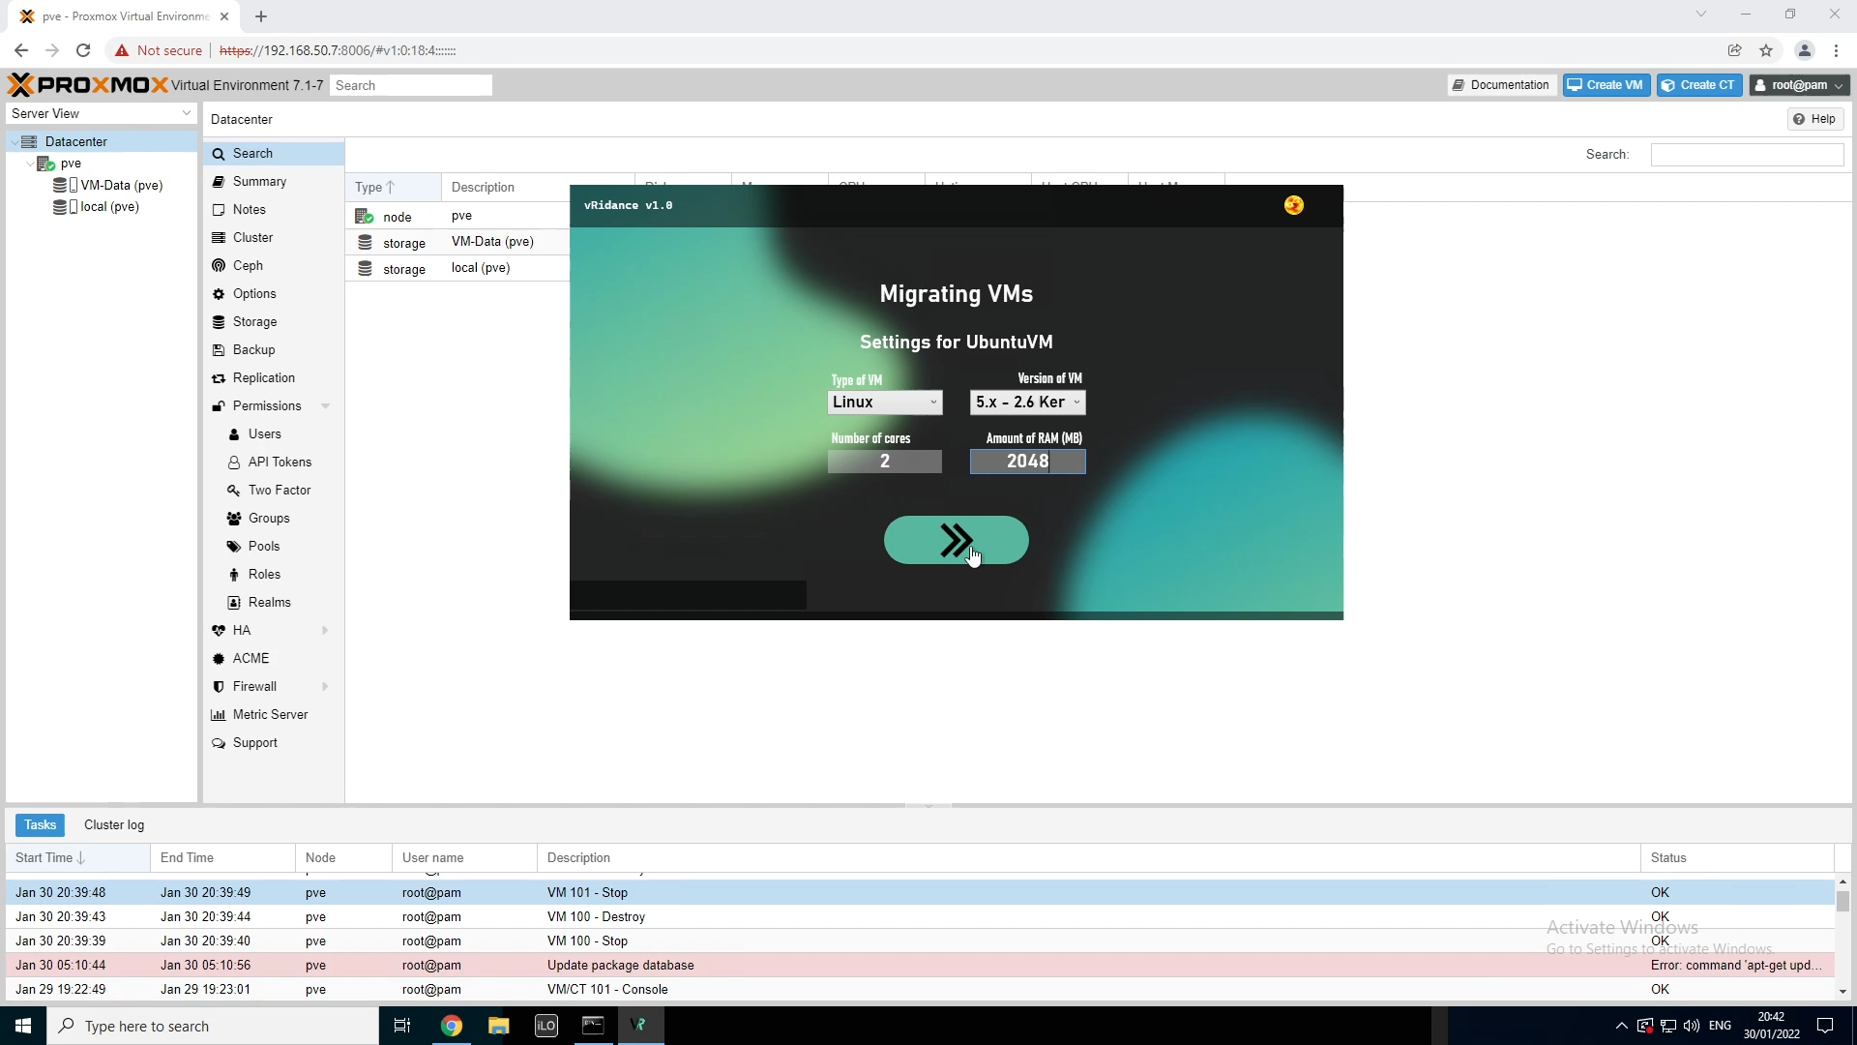

The program will automatically detect how many VMs there have to be. This is done with the amound of subdirectories there are inside of the directory you’ve selected one of the previous steps. You will be able to migrate 2 types of machines, Linux based machines and Microsoft Windows based machines. Our first VM is an UbuntuVM. So we’ll select the “Linux” type. Now choose the version of VM. In Linux you will have two different versions:

* 5.x – 2.6 Kernel
* 2.4 Kernel

In our case we will be choosing the 5.x – 2.6 Kernel with 2 cores and 2 GB (2048 MB) of RAM.

Click next to start the migration of the VM.

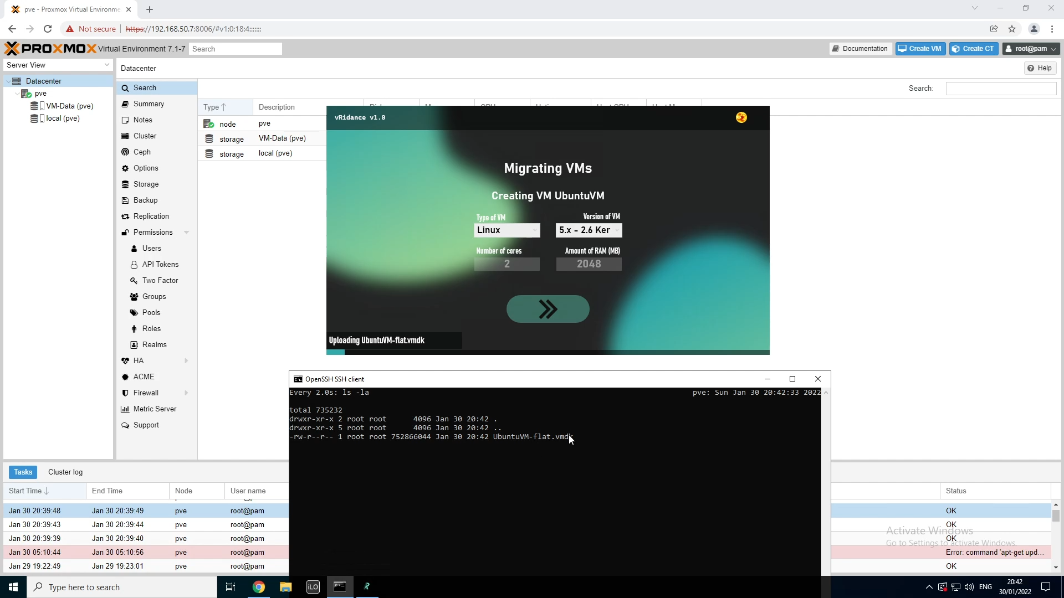

I’ve opened a command line and connected with SSH to the server. In this session I’ve navigated to the directory where the VMDK is being uploaded. In the code, the VMDKs will be uploaded to  
“/usr/src/<DirectoryName>”. Here the name of the directory is UbuntuVM. In this directory I’ve issued the command “watch ls -la” to see the progress of the upload. (this step is not necessary, because you’ll see a progressbar appear in the program)

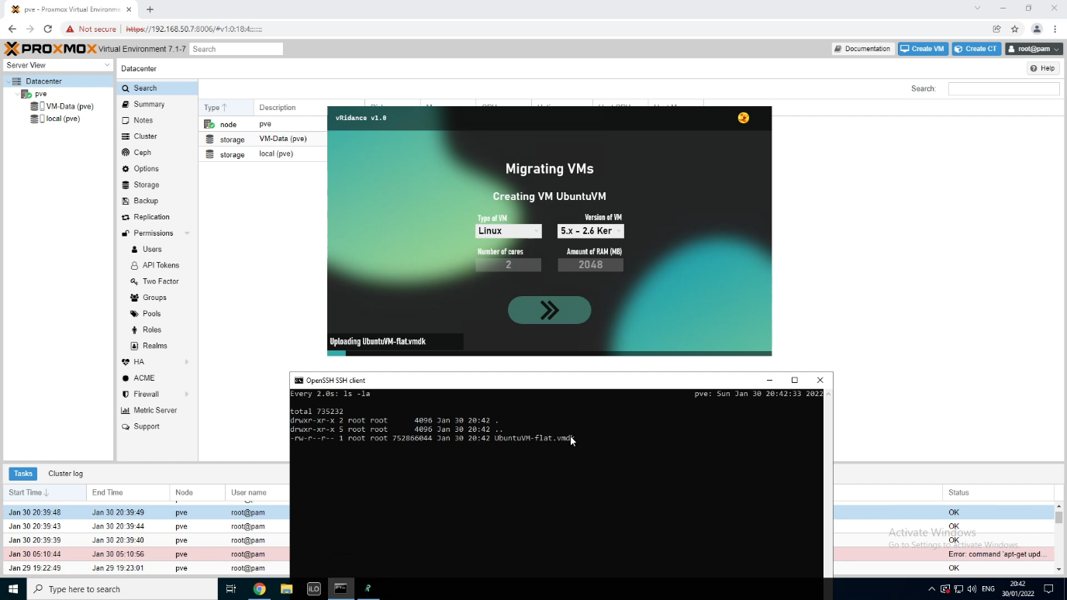

Now we’ll wait until the **\*.vmdk** and the **\*-flat.vmdk** files have been uploaded.µ

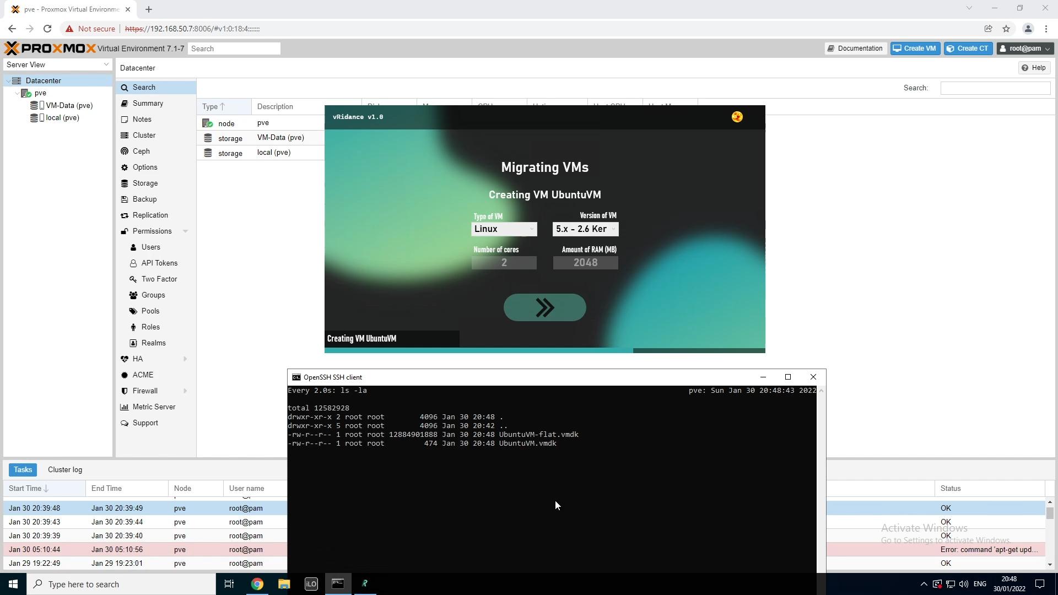

Once the two files have been uploaded, the program will create a VM with the settings we’ve provided.

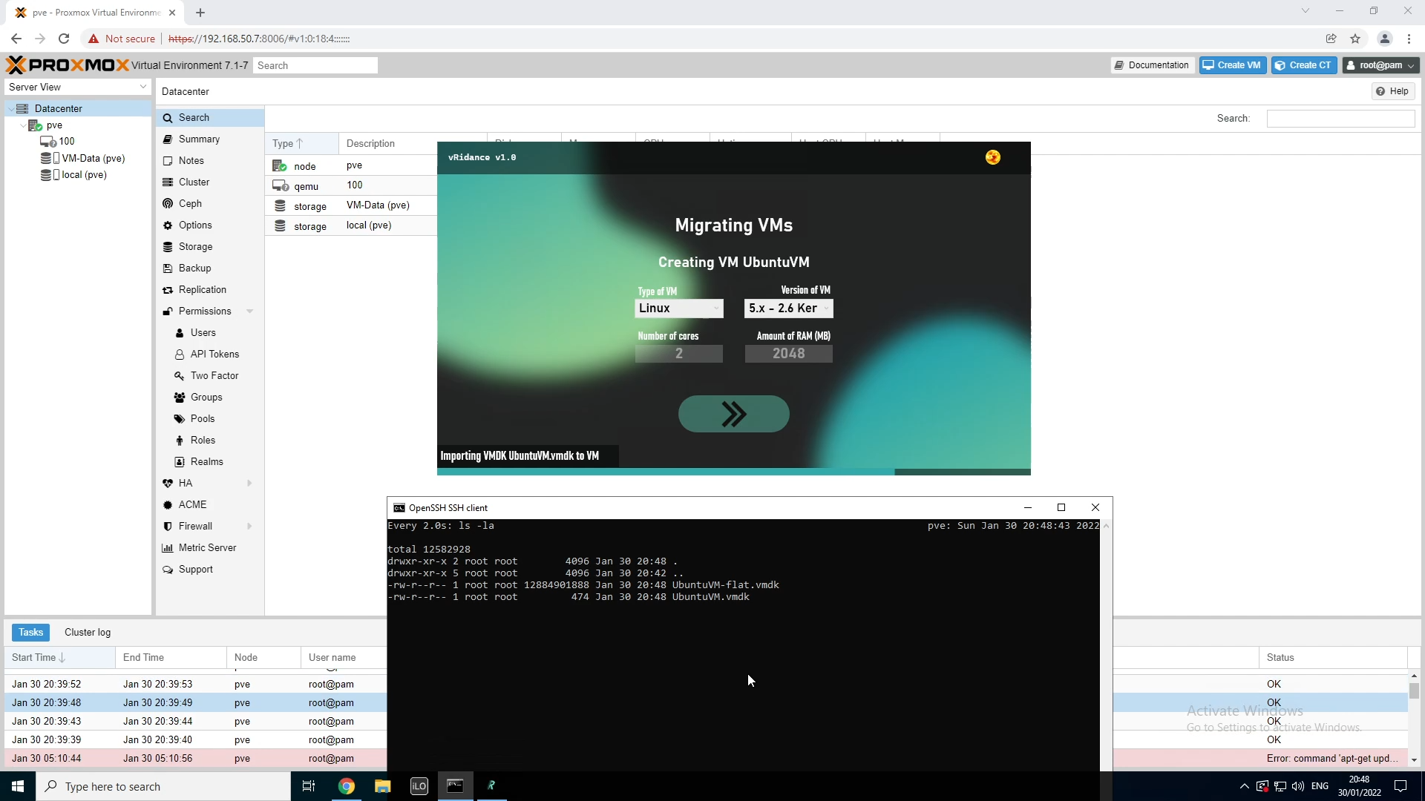

Once the VM has been created, you’ll have to import the VMDK as a RAW virtual disk. This step will automatically link the virtual disk and mark it as “Unused Disk”.

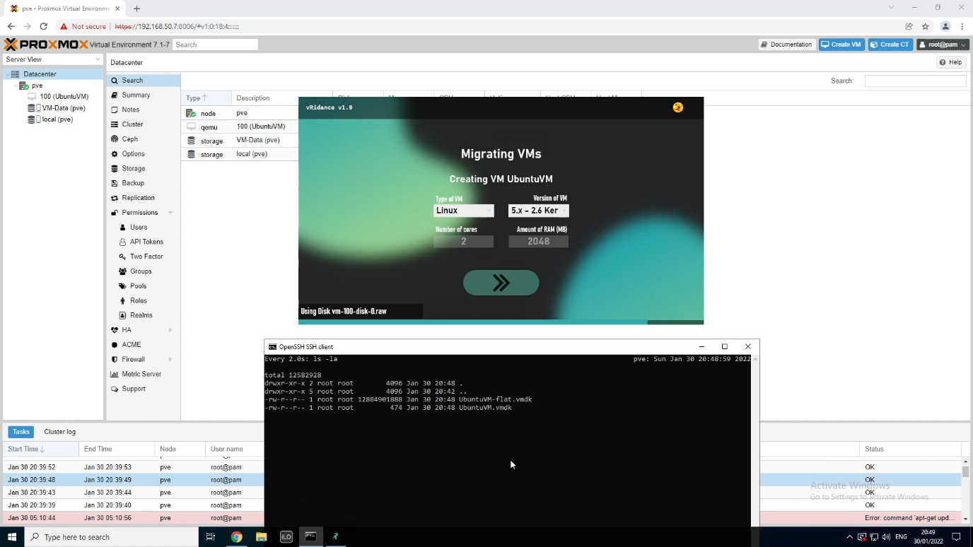

In this step, the program will use the disk. As you can see, the disk that has been imported, got the name **vm-<vmid>-disk-0.raw**.

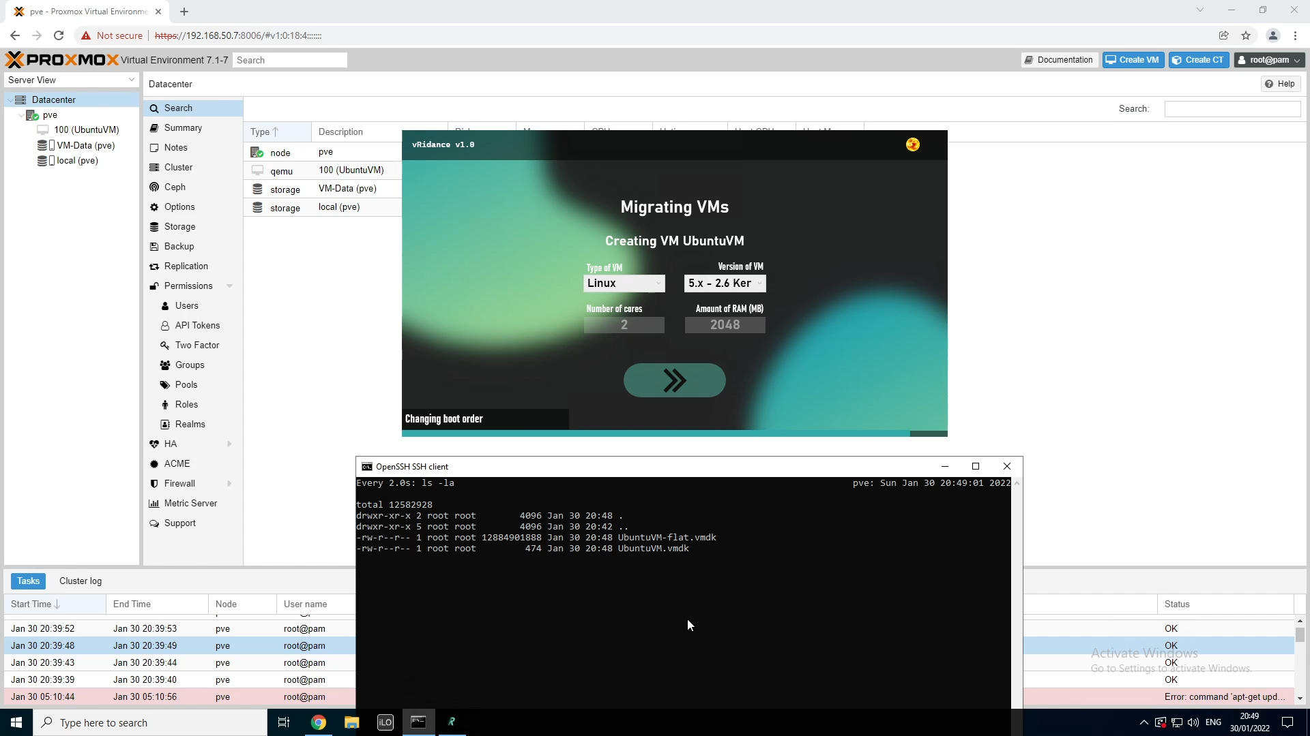

Once the VM is imported and used, you’ll still have to allow the VM to boot from the disk, this is the step where it’ll allow to boot from the disk and also puts the disk in first priority to boot from.

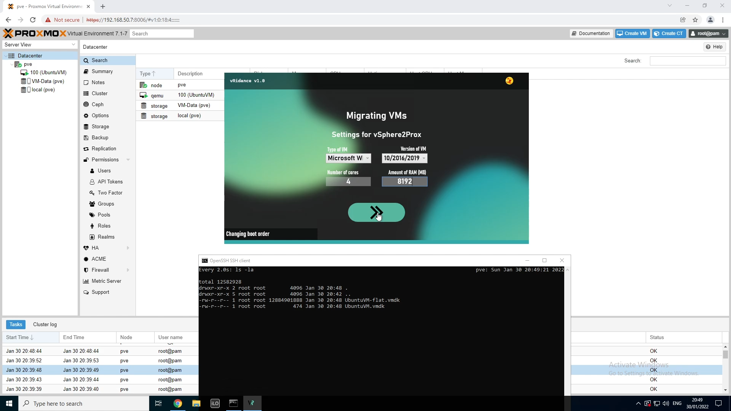

After the first VM has been created, we’ll have to select the settings for the new VM.

In the previous steps I’ve shown the different versions of VMs that you can have with “Linux”. Now we’ll be creating a Windows Machine. If you select the “Microsoft Windows” type, you will have the following versions to chose from:

* 11/2022 (Windows 11 / Windows Server 2022)
* 10/2016/2019 (Windows 10 / Windows Server 2016 & 2019)
* 8.x/2012/2012r2 (Windows 8 / Windows Server 2012 & 2012r2)
* 7/2008r2 (Windows 7 / Windows Server 2008r2)
* Vista/2008 (Windows Vista / Windows Server 2008)
* XP/2003 (Windows XP / Windows Server 2003)
* 2000 (Windows 2000)

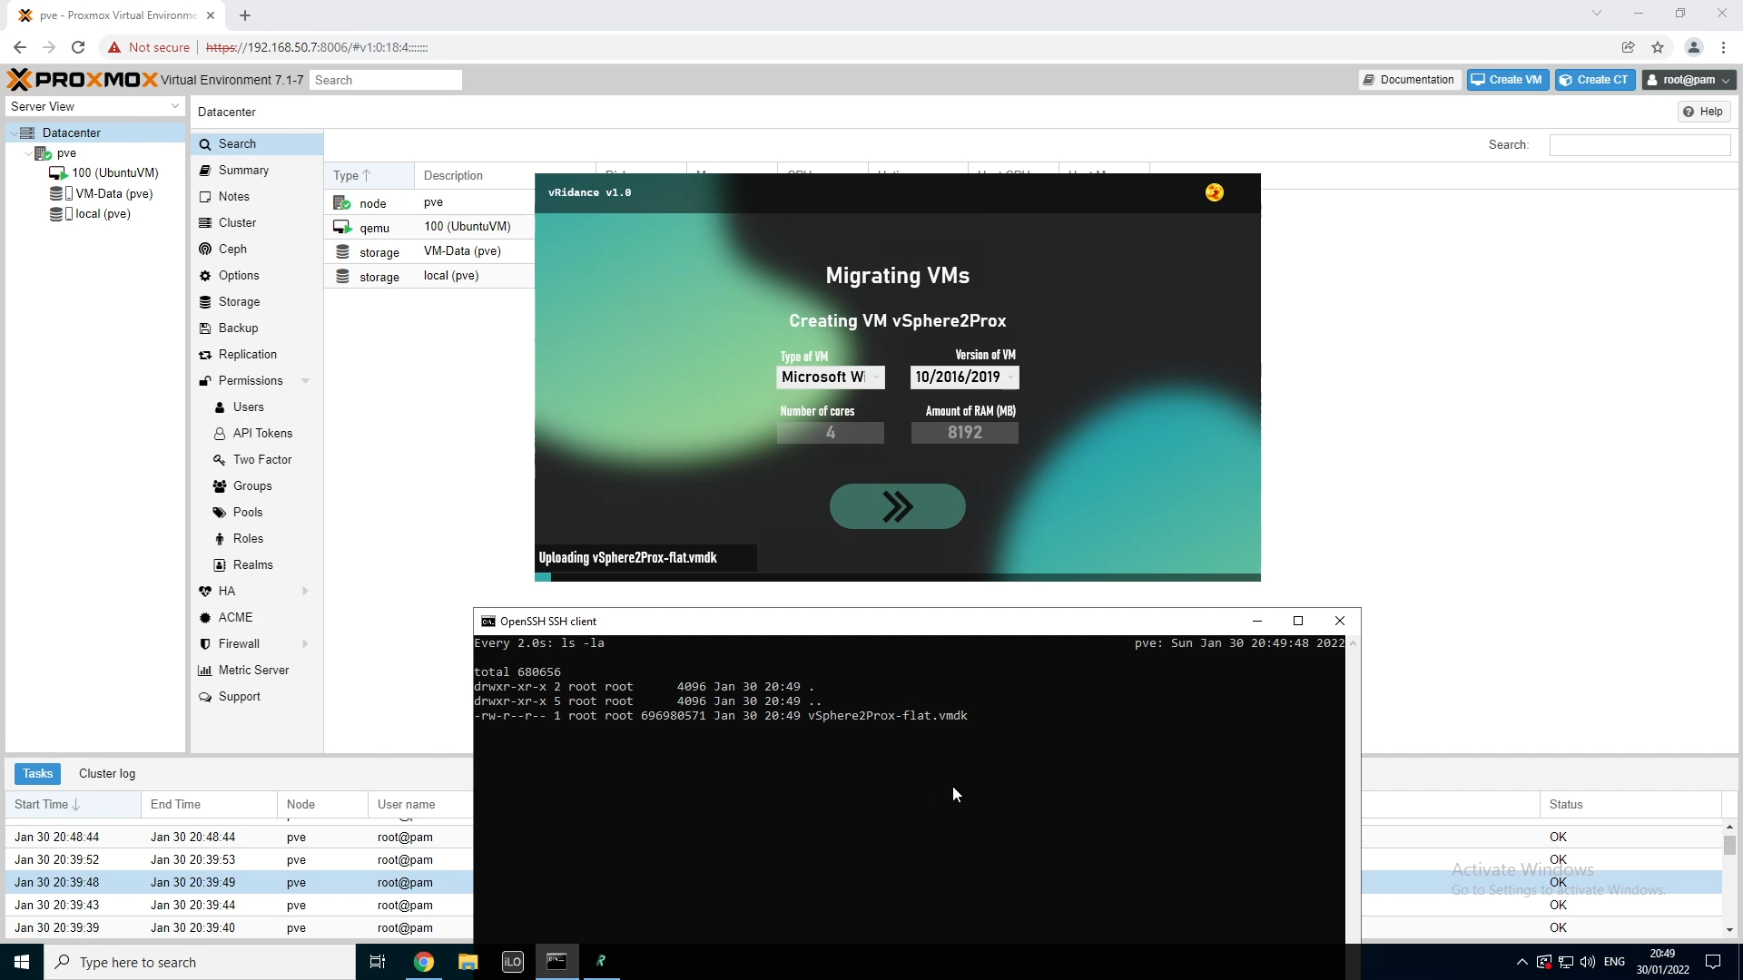

Here I’ve also issued the “watch ls -la” command in the “/usr/src/<DirectoryName>” directory.

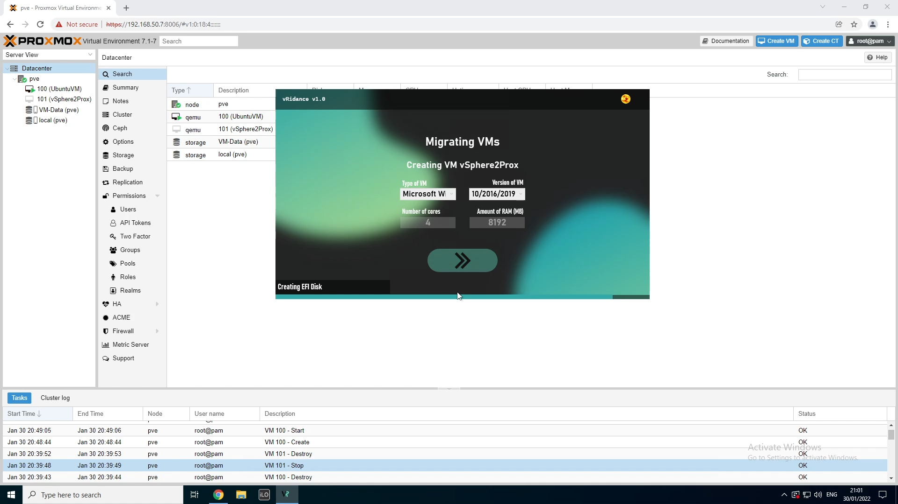

Here, the same steps as creating a linux VM will be the same:

1. Uploading the **\*-flat.vmdk** file
2. Uploading the **\*.vmdk** file
3. Creating the VM
4. Importing the disk
5. Using the disk
6. Changing the boot order

The Windows VM that I want to migrate is using an UEFI boot mode. With UEFI, we’ll need an EFI disk. This step will create one.

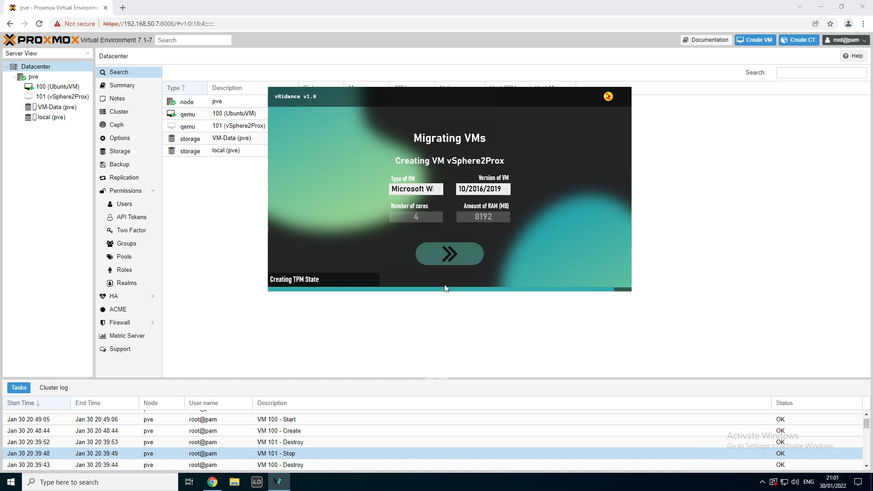

If you ever want to upgrade the VM from a Windows 10 VM to a Windows 11 VM, you’ll need a TPM module. In this step this module will be created.

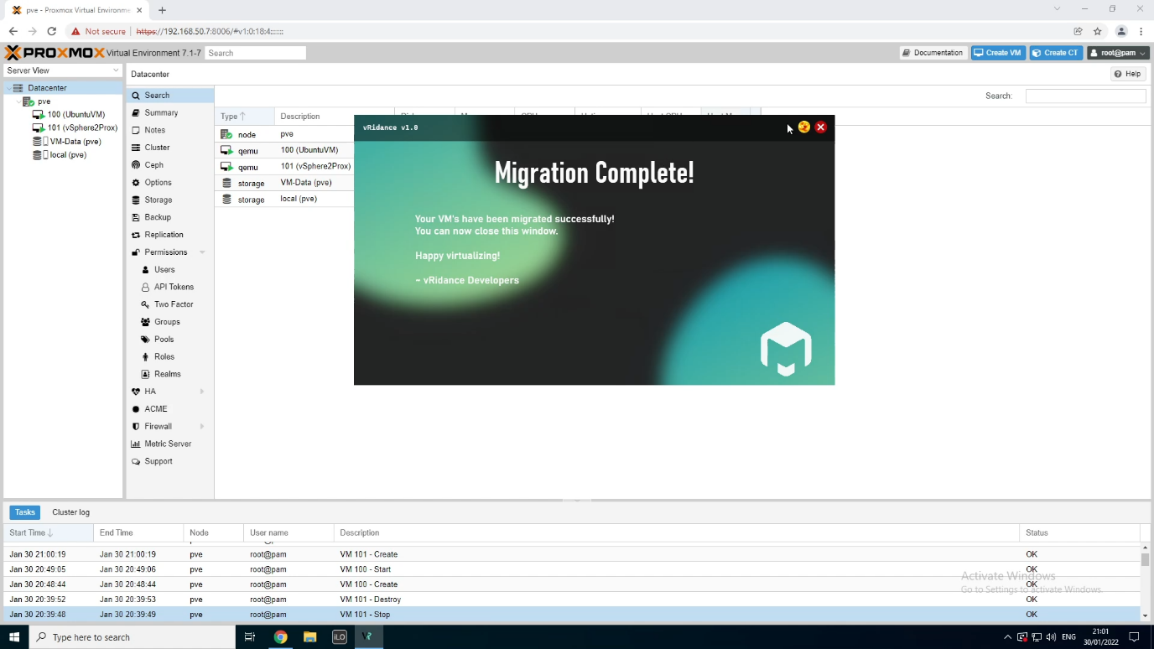

After all the machines have been migrated, you can close the program. Let’s go see the result!

## Logging in to the Proxmox VE Web Interface

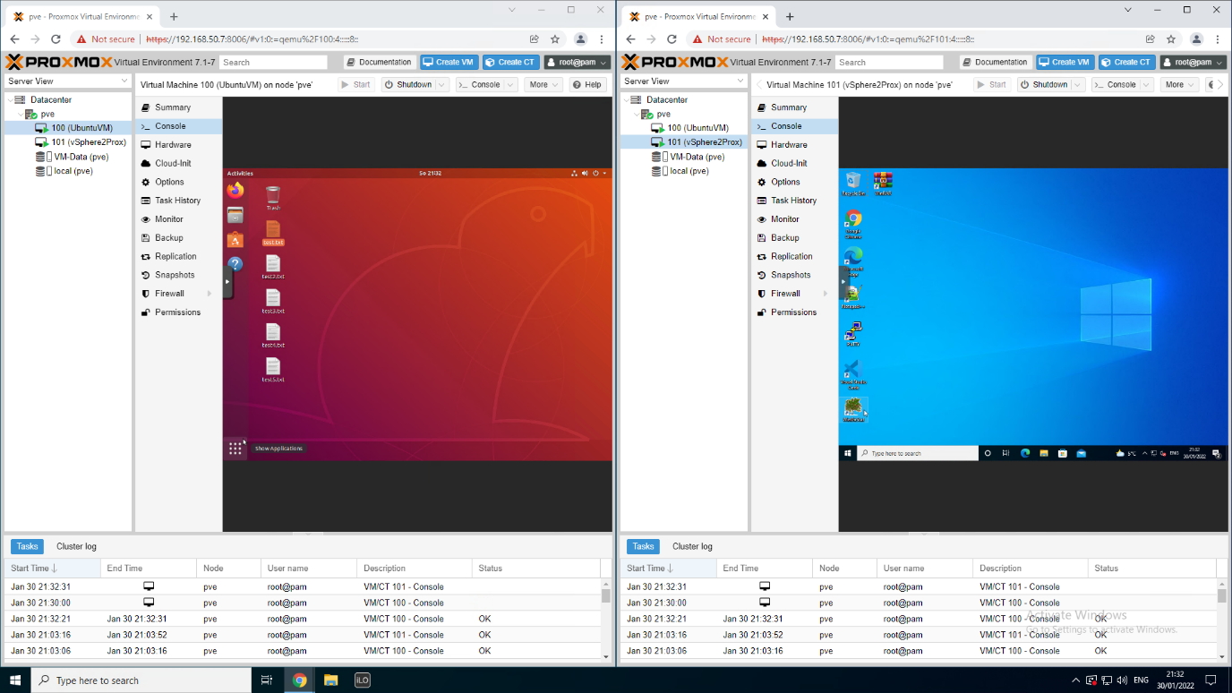

Now that the migration is complete, we can see the result of the program. As you can see, an Ubuntu VM and a Windows VM have been created and booted.

On the Ubuntu VM, you can see that the files created on the vSphere VM have also been successfully migrated. In this case every file has the same data in it, but there is no data loss.

The Windows VM is connected to a domain. Because Windows has detected a new network card, the DNS configuration has been wiped. There is a script running on startup that changes the DNS server on the detected Network Interface to the IP of the Domain Controller.

But this was it! You’ve successfully migrated your virtual machines from vSphere to Proxmox without a hassle. Happy virtualizing!

# Azure Stack HCI

In this chapter we will demonstrate how you can migrate your VMs from vSphere to Azure Stack HCI.

## Select your VM

Log into your vSphere environment and locate a VM you want to migrate.

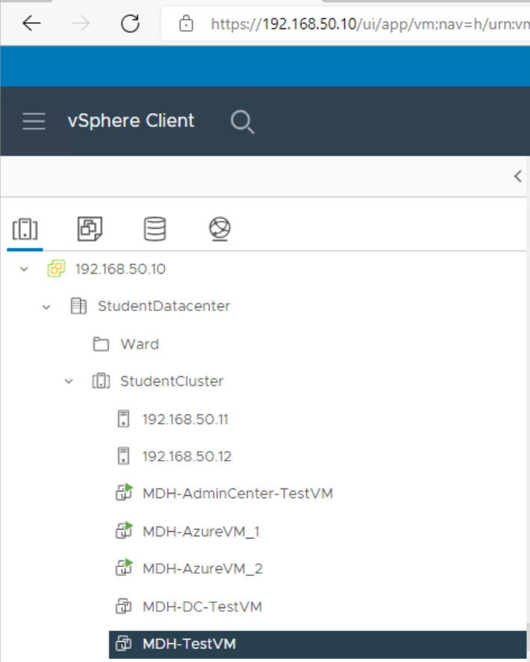

After you selected your VM go to the datastore tab, in my case my VM is stored on ESXI00.

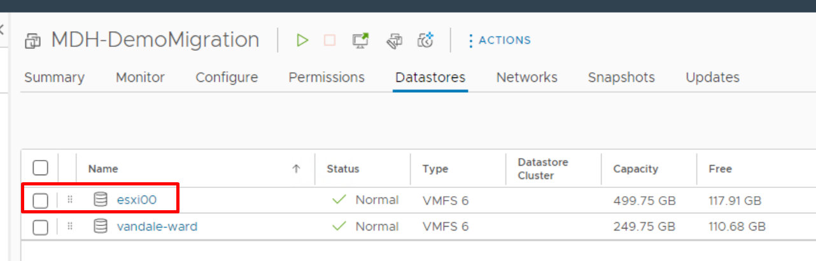

Here we select the VM and click on download. This will download all the files we need for the migration.

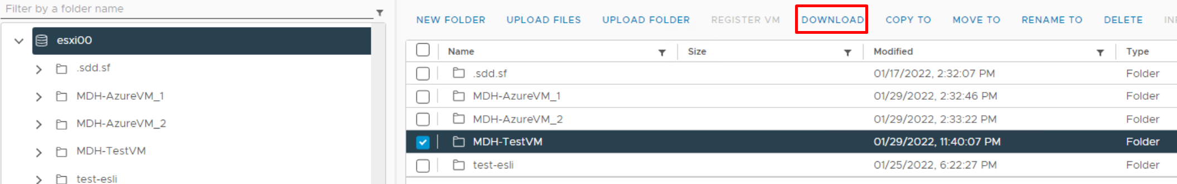

Now in the downloads folder we can see this.

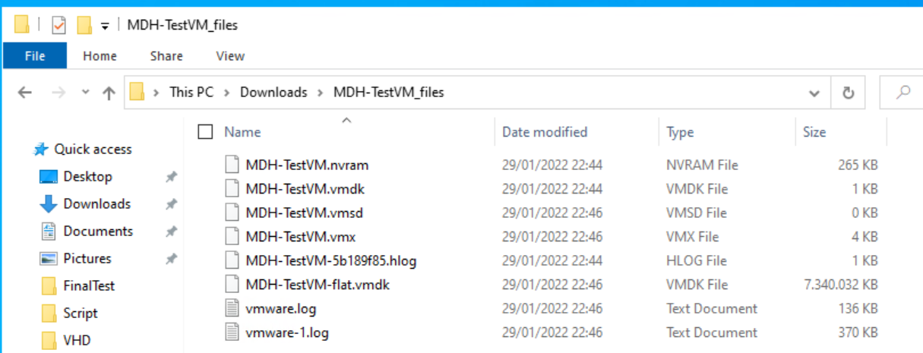

## Convert vmdk to vhd

In order to migrate we need to convert the MDH-TestVM.vmdk file to a vhd file. Vhd is supported on Azure Stack HCI and vmdk is not.

But first we need a tool that converts these files.

[StarWind V2V Converter - Converting VM Formats (starwindsoftware.com)](https://www.starwindsoftware.com/starwind-v2v-converter#download)

Fill in your details and check your mailbox, there will be a download link waiting for you. Than simply install StarWind V2V Converter.

Now on the desktop create a new txt file and call it “!Converter.cmd”. Edit the file and past the following:

SET vmdkFilePath=""

SET vhdFilePath=""

V2V_ConverterConsole.exe convert in_file_name=%vmdkFilePath% out_file_name=%vhdFilePath%

Or in the sources folder we provide you can copy and paste !Converter.cmd in the StarWind V2V Converter folder, see further in the document for the path.

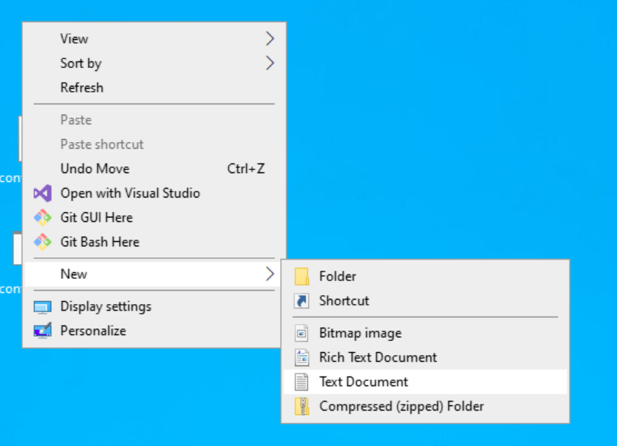

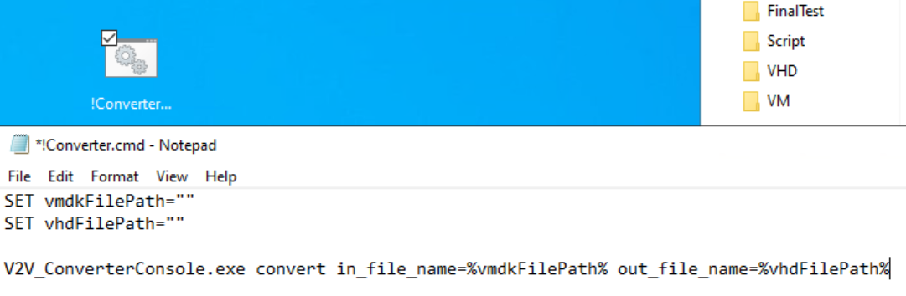

Or go to the sources folder we provided and copy and past!Converter.cmd inside the StarWind V2V Converter folder.

You can save and close the file. Now go to this path:

C:\Program Files\StarWind Software\StarWind V2V Converter

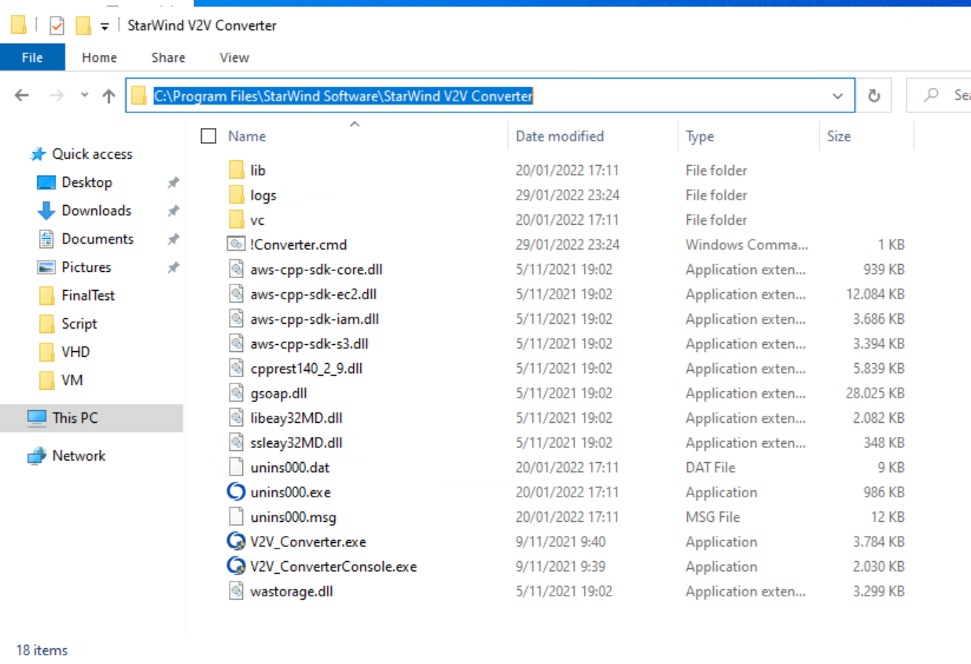

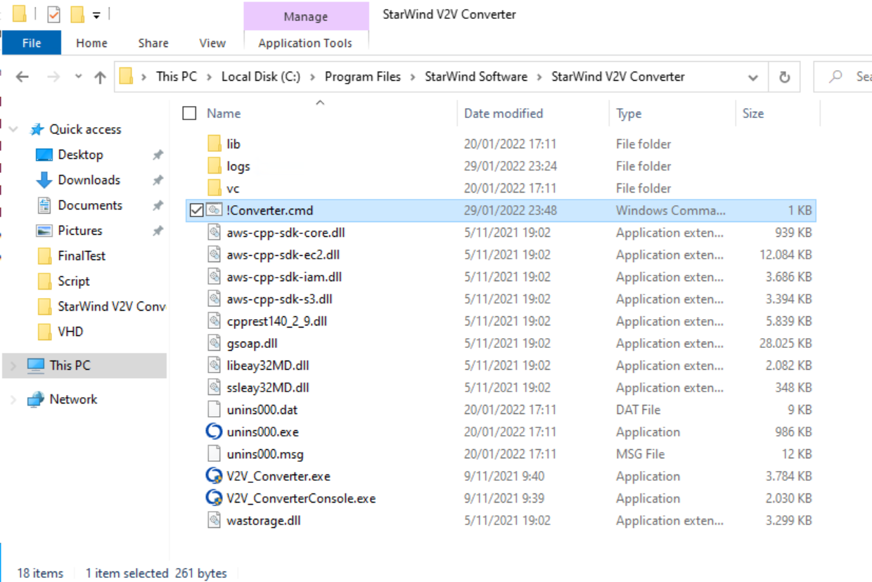

Now we can start converting the vmdk file very easy with this small script. Edit !Converter.cmd with notepad (++).

Now we have to specify the paths.

* vmdkFilePath = is the current location of the vmdk file you just downloaded from the VM
* vhdFilePath = is the location where you want to store the vhd file



Save and close notepad. Double click on !Converter.cmd and wait for it to load. After it is finished you should see a vhd file in your specified location.

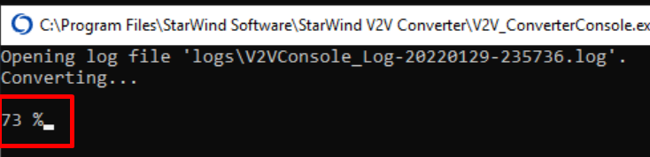

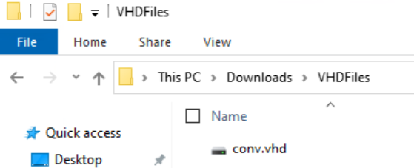

Now cut and paste the vhd file in to the cluster storage. We must copy past this because if we convert and immediately place it onto the cluster storage we must wait upto 3 hours to complete. And there is a lot that can go wrong, if we even lose connection the vhd file can go corrupt so the safest solution is to just copy and past them into the cluster storage.

\\win-newazure1\c$\ClusterStorage\Volume01\VHD\

## Migrate VM

Open your mgmt machine where you can access Windows Admin Center and your Azure nodes.

In the sources folder we provided you can find all the necessary files. Simply place them on one of your nodes. In my case I put them here:

\\win-newazure1\c$\Users\administrator.MDH\Documents

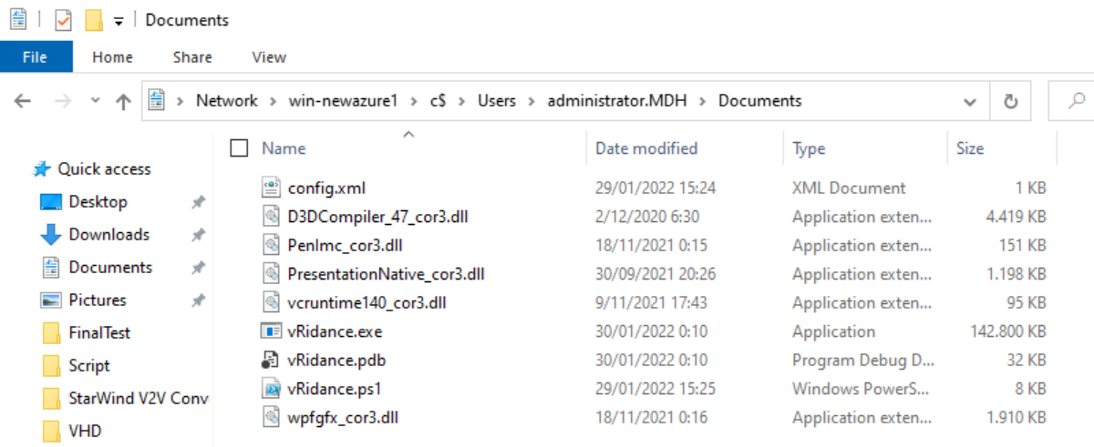

Dubbel click on vRidance.exe, this will open the GUI.

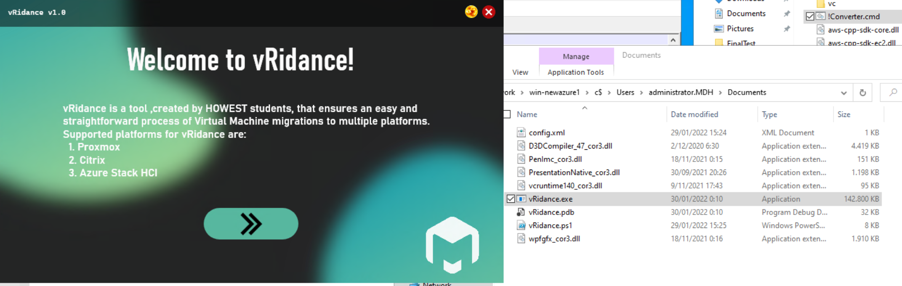

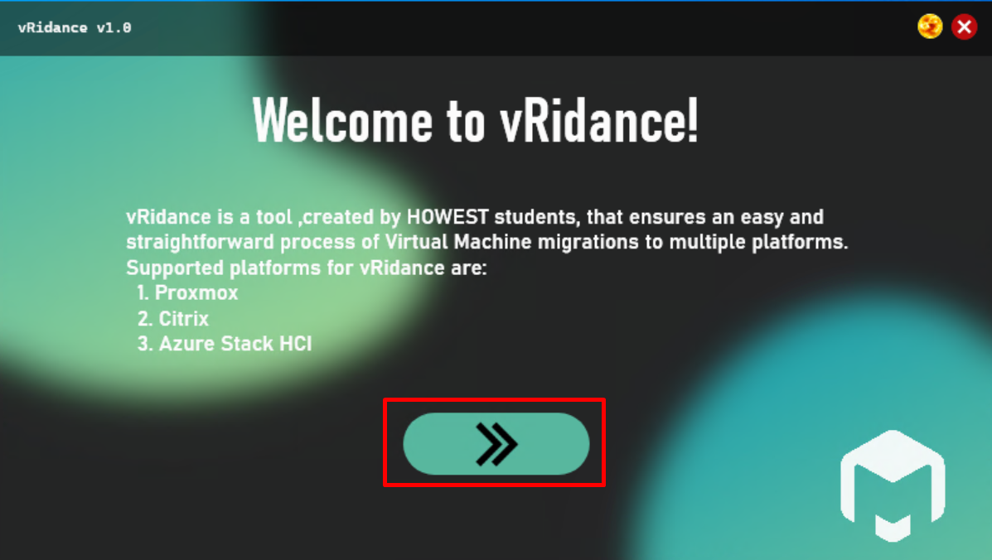

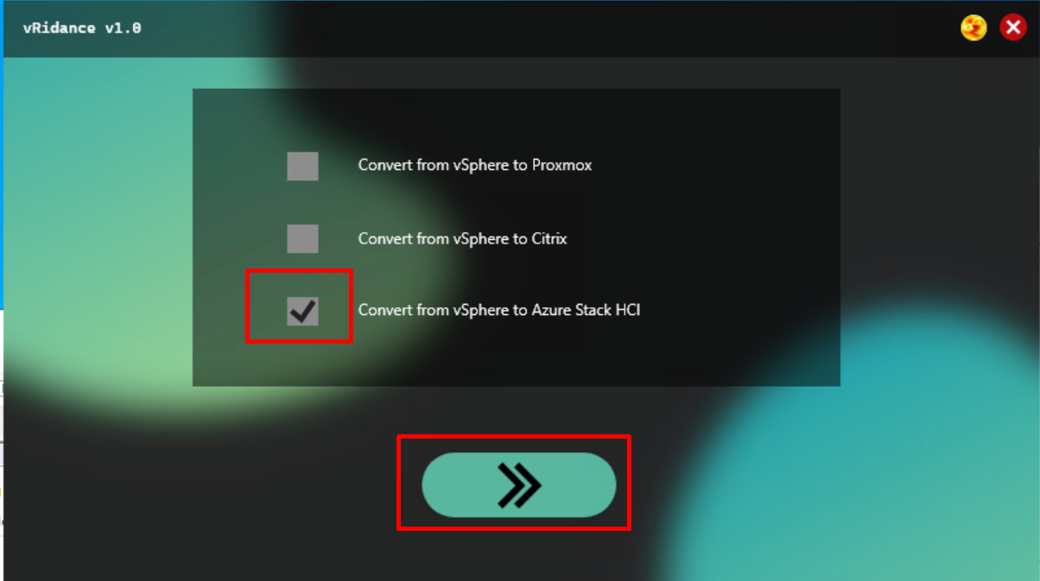

In this window we fill in all the configurations for the VM.

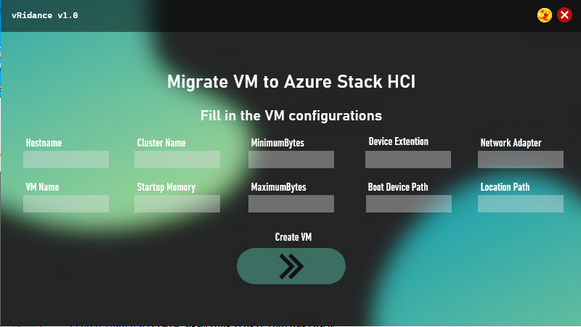

* Hostname = The name of the Host where the VM is being placed
* VMName = Name of the VM
* ClusterName = Name of the cluster where we place the VM
* StartupMemory = How much memory we give at startup
* MinimumMemory = Minimum memory we give to the VM
* MaximumMemory = Maximum memory we give to the VM
* Device Extention = Extention of the harddisk file
* Boot Device Path = Location of the harddisk file
* Network adapter = Name of the network adapter
* Location Path = Location where we store the VM

Example:

* Hostname = Win-newazure1
* VMName = WindowsServer2022-001
* ClusterName = ClusterV2
* StartupMemory = 4GB
* MinimumMemory = 1GB
* MaximumMemory = 4GB
* Device Extention = VHD
* Boot Device Path = c:\diskpath\disk.vhd
* Network adapter = ComputeSwitch
* Location Path = c:\storagepath\

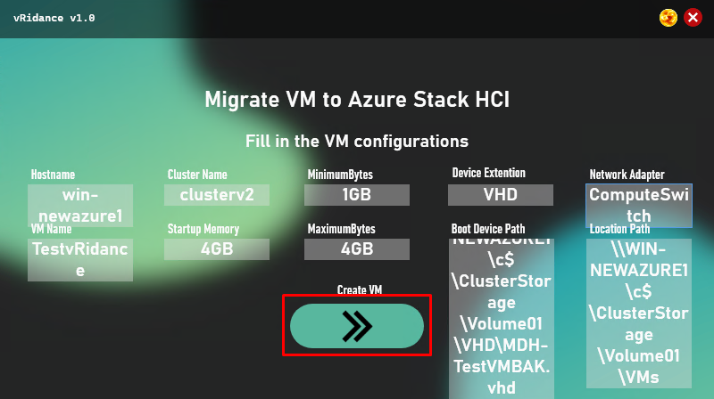

Now go to the machine with the hostname you typed in. In my case I used “win-newazure1”.

In the source folder copy and past all these files inside the document folder of the user.

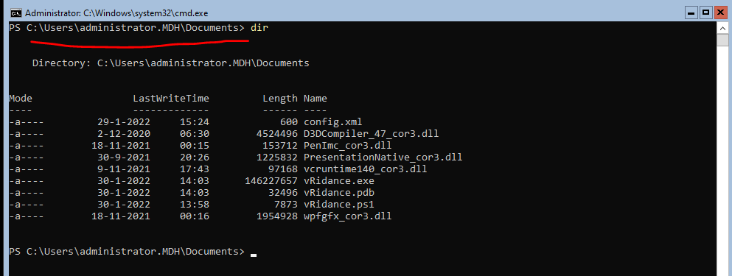

Why must we do this? Well the GUI works with WPF and this eis not supported one these Azure nodes and we only found this out at the last moment.

Now we use a mgmt machine to start and complete the GUI. The GUI makes the config.xml file and after that we go to the Azure Node VM (the hostname we specified) and run vRidance.ps1

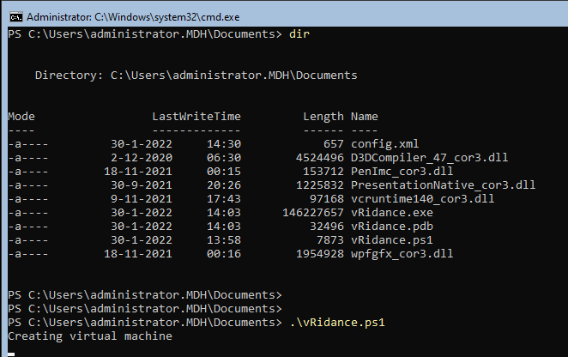

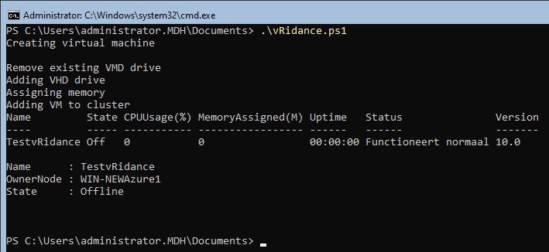

After this is complete open Windows Admin Center and log into the cluster. Here you can see the VM we just created.

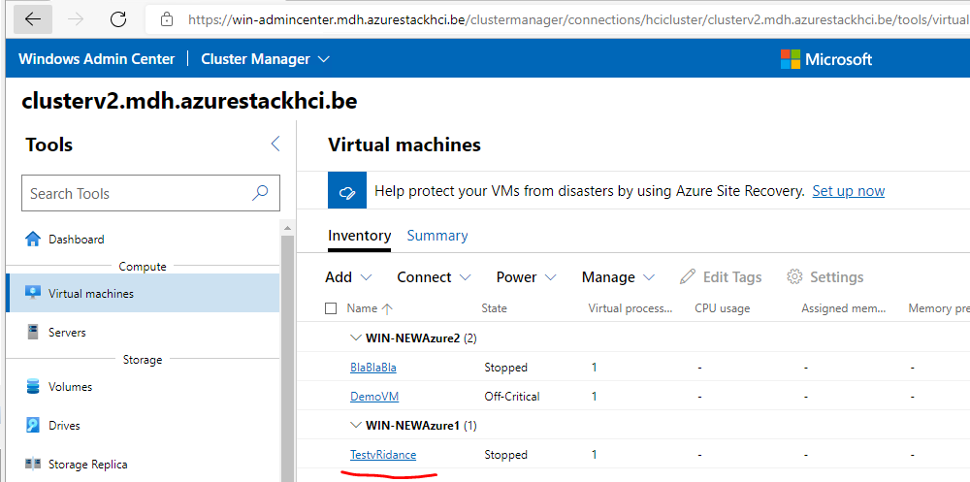

# Citrix

## Installing the vRidance Tool

To install the vRidance tool, head over to our github repository and download the latest version.

After downloading, you are prompted with the following files;

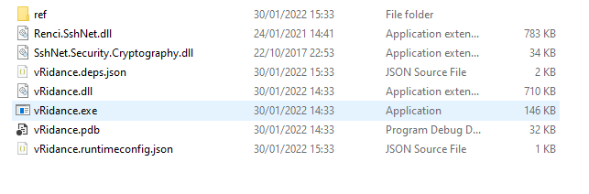

You can save these in a directory of choice, or run the vRidance.exe straight from the downloads folder.

## How to use vRidance

After you have downloaded the vRidance Tool from our github repository, you can double click the vRidance.exe to start up the program. You will be prompted with the following screen;

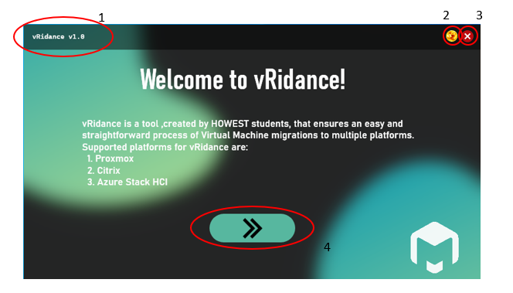

Highlighted info:

1. Version
2. Toggle button for light/dark themed UI
3. Close button
4. Next button

You can click on the Next button to continue to the next page.

You will be prompted with the following screen;

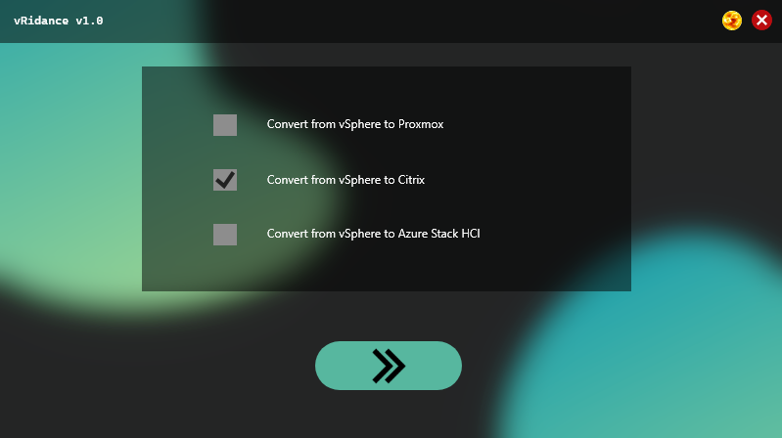

Choose a platform you want to migrate to by clicking one of the checkboxes. In this case, we will be using Citrix. You can now click on the Next Button.

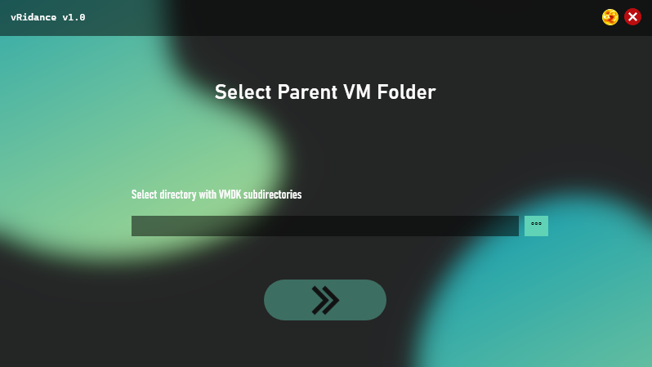

In this screen, you will select your VMDK parent directory. This directory will contain subfolders where your VMDK files will be present. The Directory should look like the following picture below;

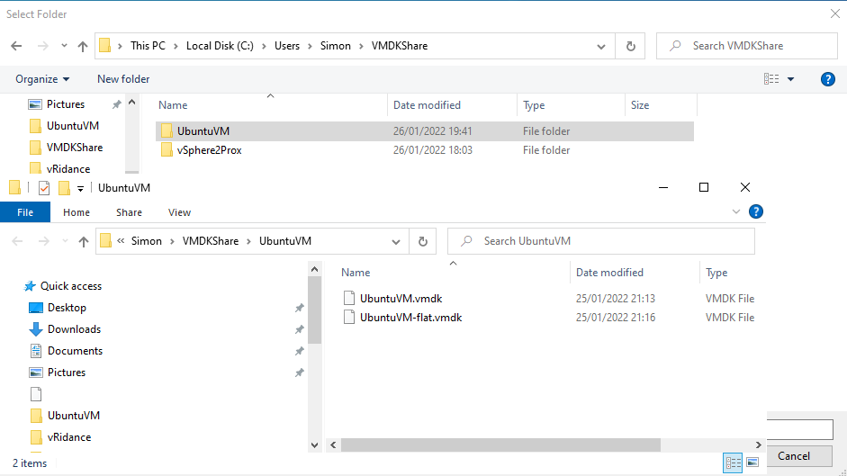

In other words, VMDKShare > VMNAME > VMDK Files

Do note, the Child directory containing the VMDK files will be the name of your imported VM. (UbuntuVM, vSphere2Prox) Choose your names wisely as they will be useful at a later stage during the migration.

After selecting the VMDK Directory, you can click on the Next Button. You will then be prompted with the following screen;

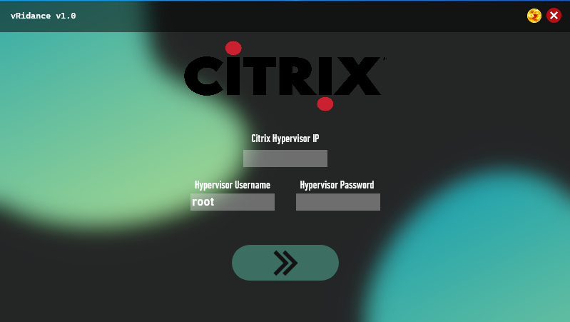

This is the Citrix Hypervisor login screen. Here you will provide the details to connect with your Citrix Hypervisor. After that, we can click on the Next Button.

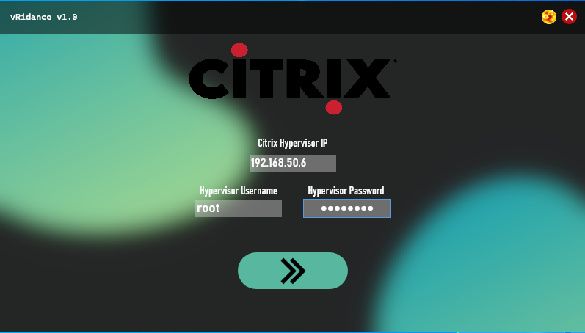

You will then be prompted with the following screen;

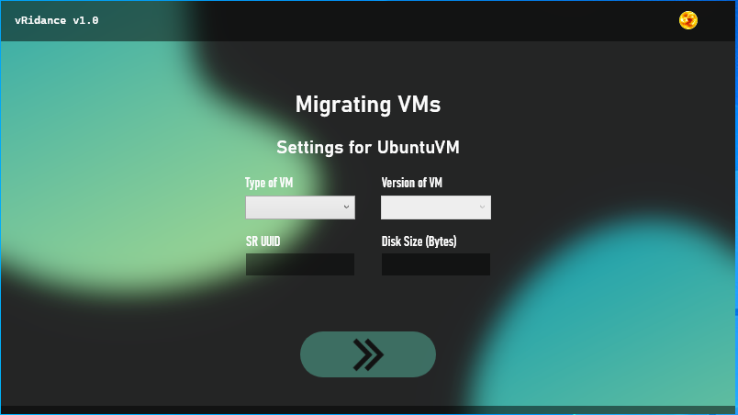

This is the screen where all of your migrations will take place. Remember the Child directory from the VMDKShare Directory? This is used to display which VM you will be installing. For UbuntuVM, since this is a Linux machine running Ubuntu Bionic Beaver 18.04 from vSphere, we’ll give it the same Type and Version of VM.

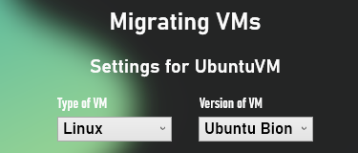

The next parts contain the Storage UUID and the Disk Size in Bytes.

The storage UUID can be found on Citrix Xencenter under your preferred storage. I’m using local storage for this tutorial.

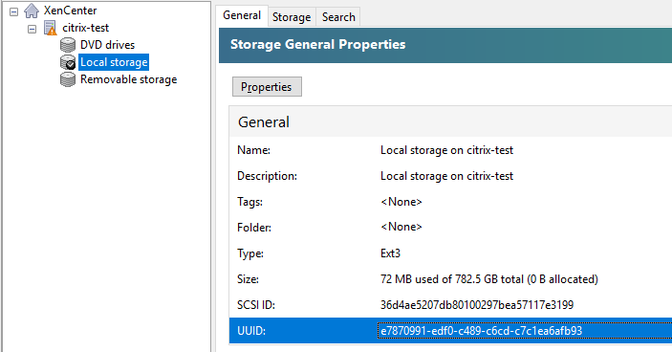

Copy this UUID and paste it in the vRidance tool where SR UUID is asked.

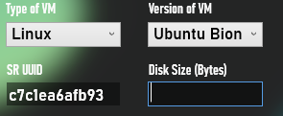

For Disk Size, you will have to look at the VMDK you will be importing. I know that the UbuntuVM is 12.4GB big, so I’ll be using 13312000000 Bytes. You can use this website to convert Bytes to GB.

<https://whatsabyte.com/P1/byteconverter.htm>

Paste your Bytes value in the Disk Size box.

You can now click on the Next Button. Your UbuntuVM will automatically be created into your Citrix XenCenter. After the UbuntuVM Migration, it will continue to the next child directory in the VMDK share (vSphere2Prox VM, which is a windows machine)

When clicking on the Next Button a progressbar will appear and info will be displayed on what is happening. A screenshot of the working migration is provided below so you can have a look first.

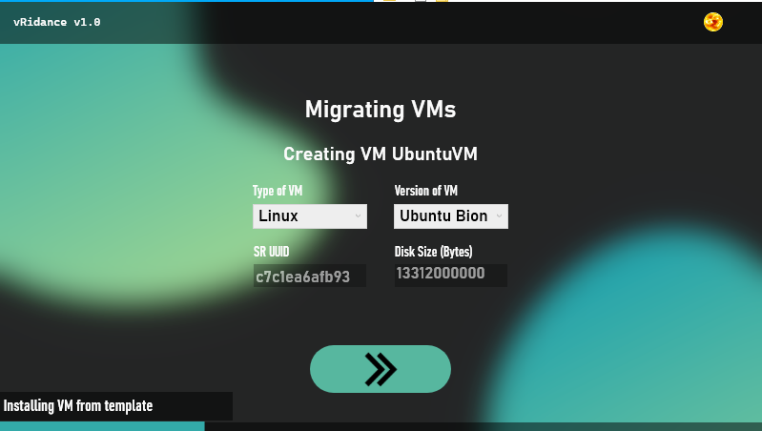  
You can leave this running until the progressbar is full. It will then move on to the next, where you will need to select the Type, Version, SR UUID and Disk Size again for the new machine.

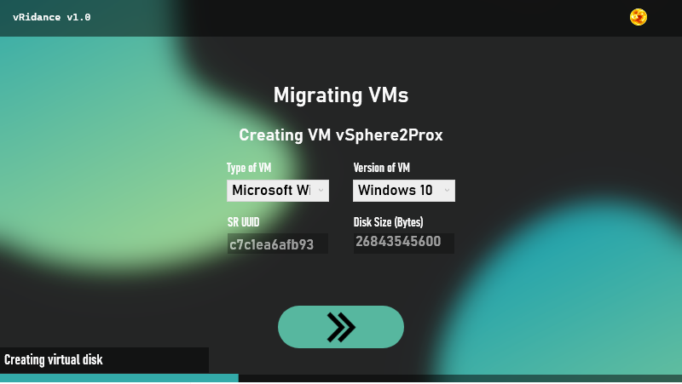

After all the migrations are successful you will be prompted with a next (and final) screen prompting your migrations have been successful.

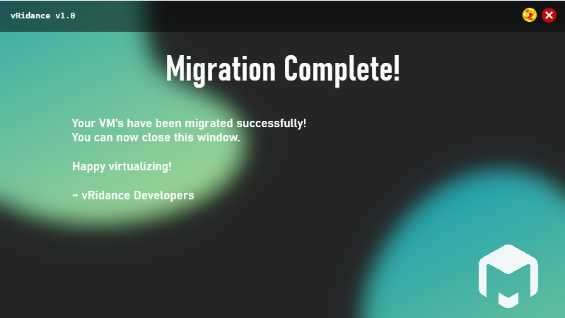

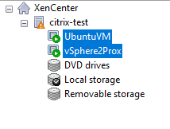

You can then close the program. If you wish to migrate more machines in the future, you’ll have to delete the old VMDK’s in the Share, and upload your new ones in the same folder hierarchy as before, run the same steps again, and enjoy your new VM’s on Citrix XenCenter!